**PHASE III –**

**FINAL ASSESMENT**

**SPORTY SHOES**

**Rajagopal Sai Krishna**

**2499086**

**Outputs:**

**Login:**

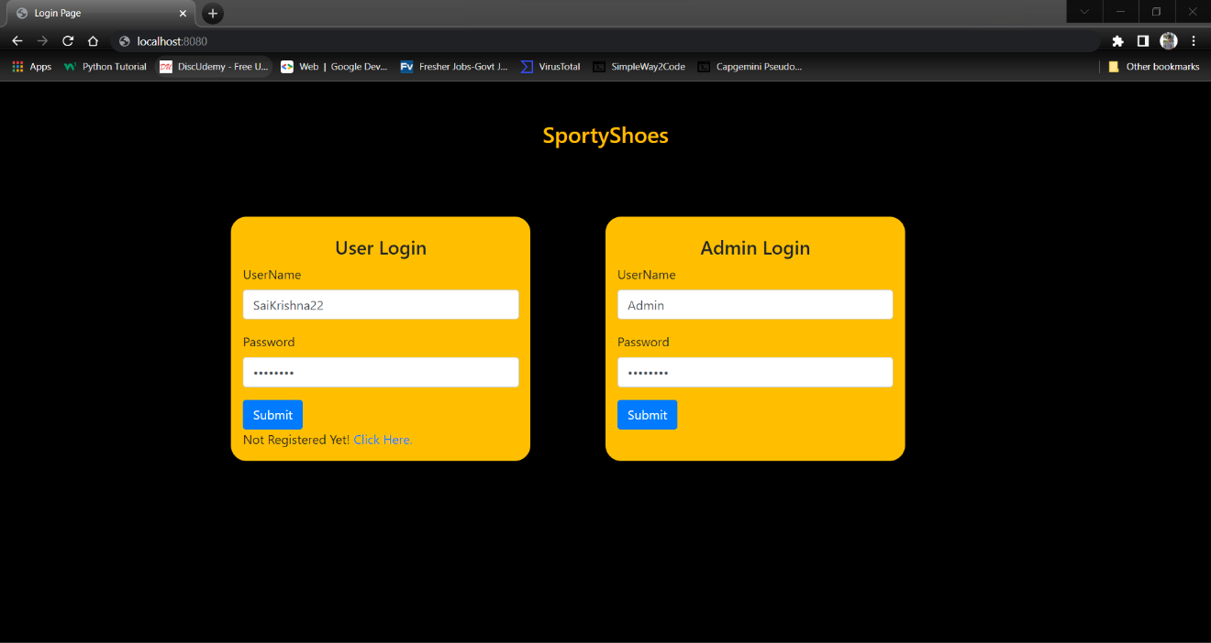

**Admin Home:**

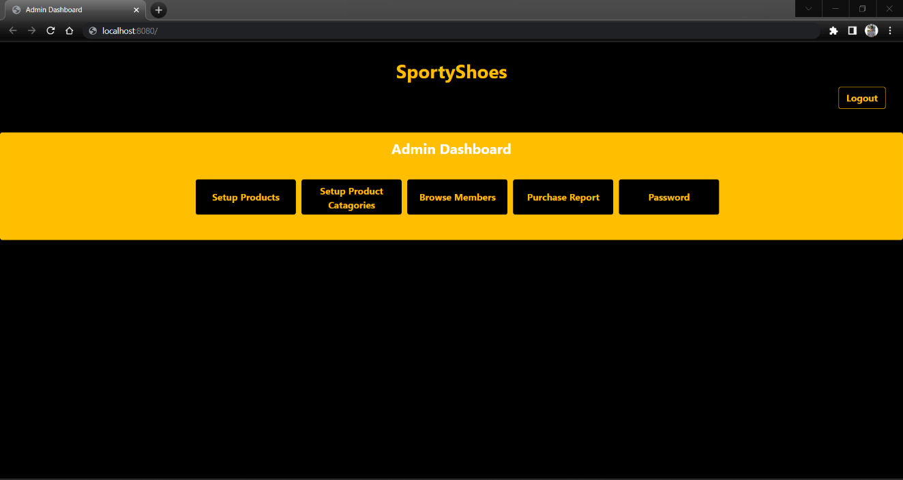

**Category Addition:**

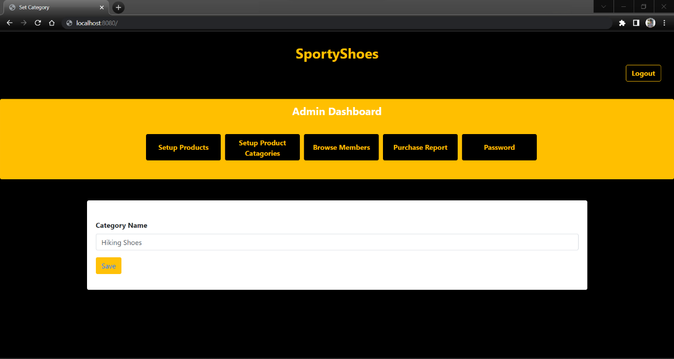

**Show Category:**

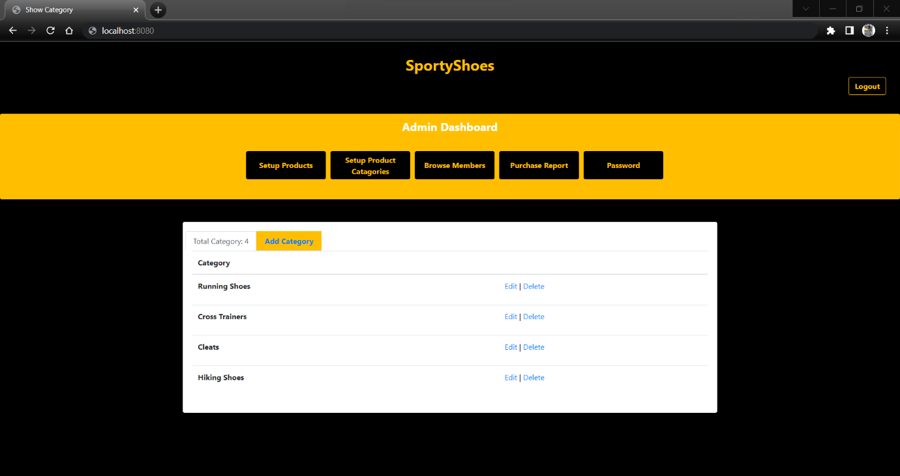

**Product Addition:**

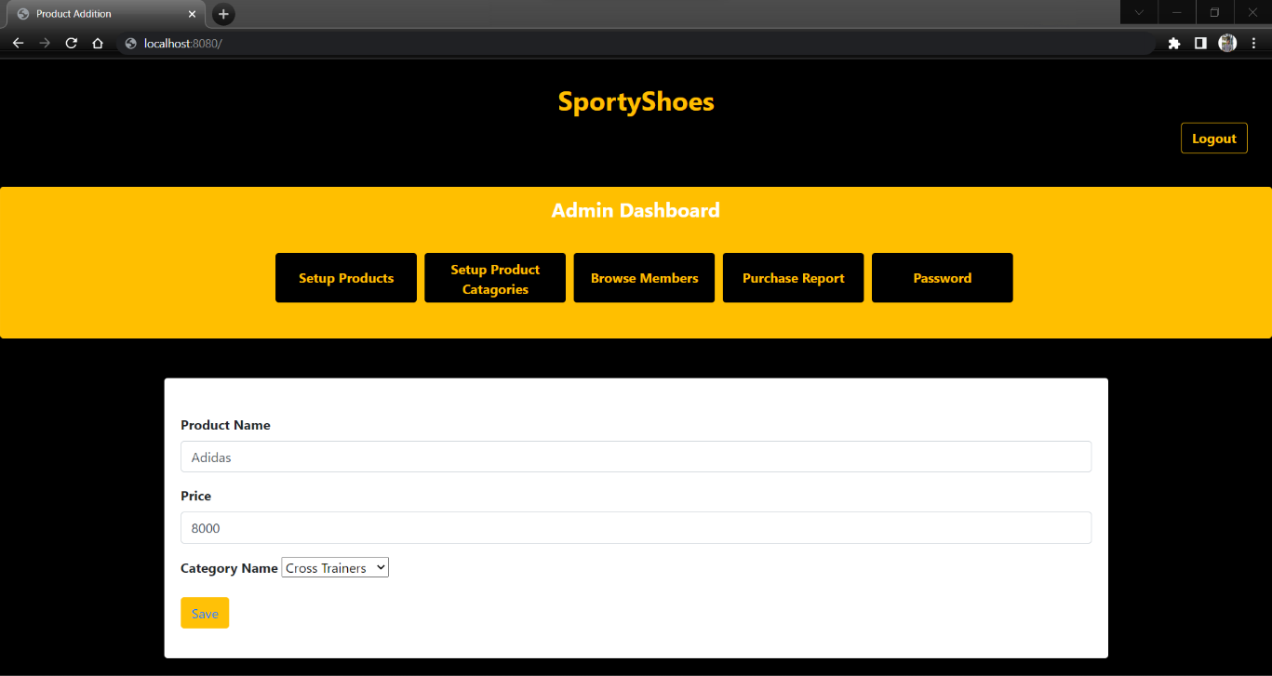

**Show Product Details:**

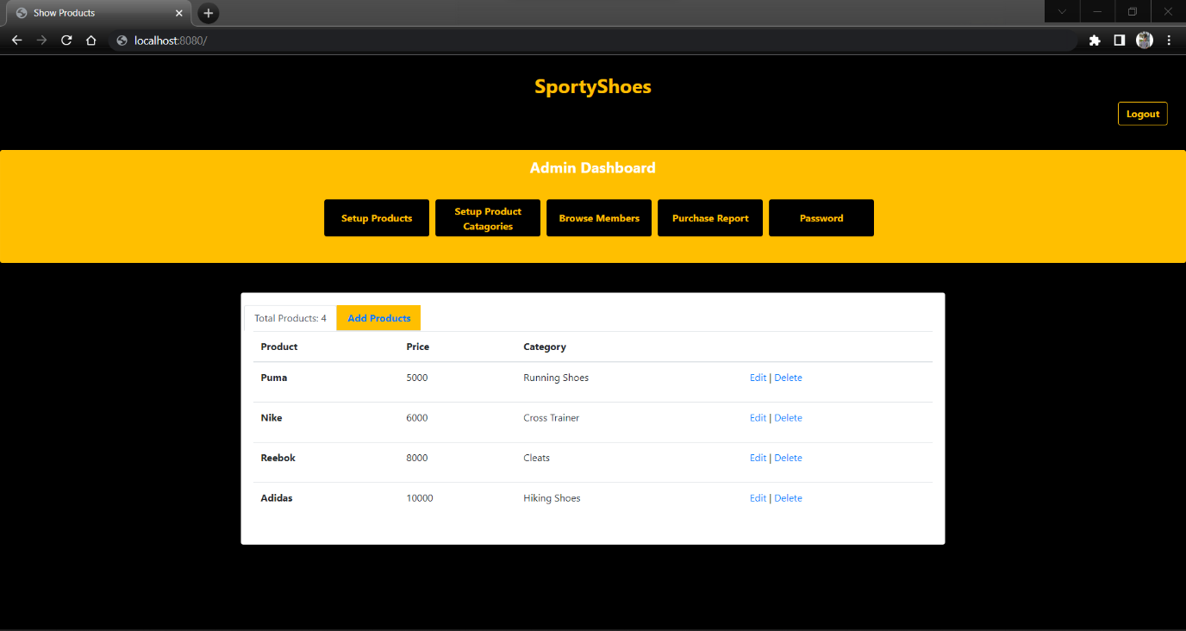

**Browse Members:**

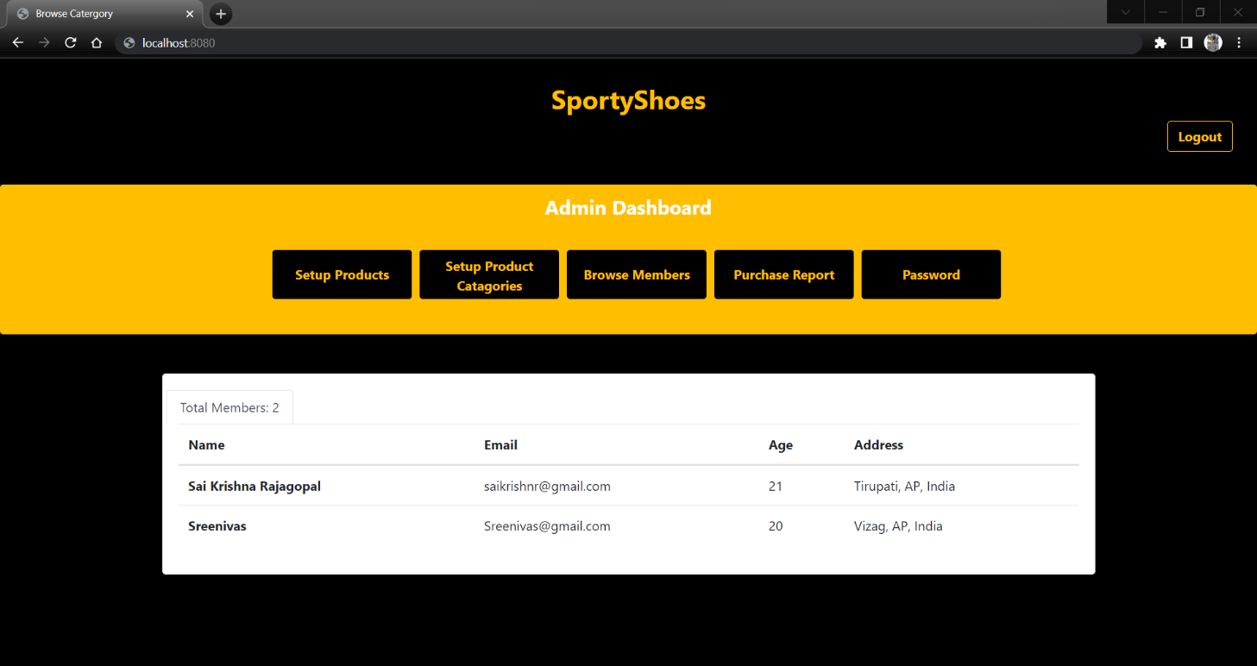

**Purchase Report:**

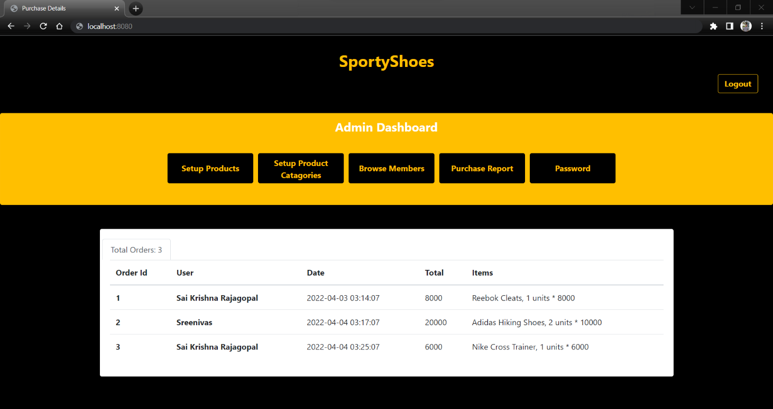

**Admin Password Change:**

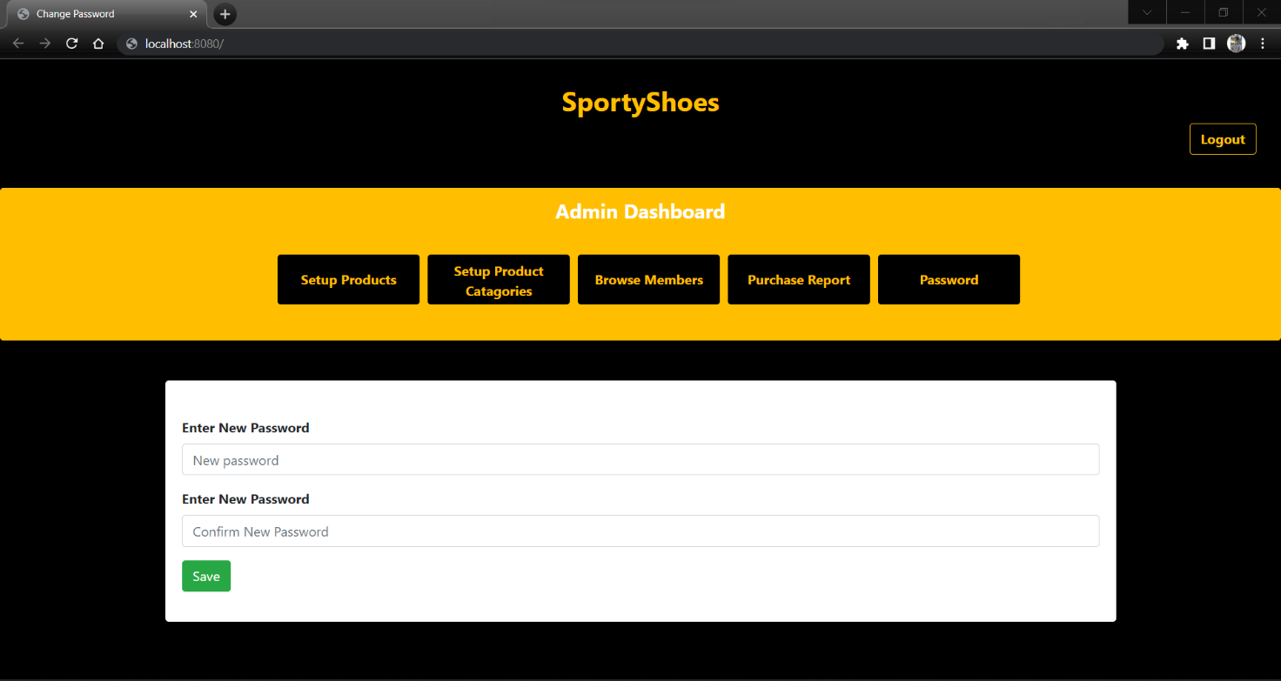

**Registration:**

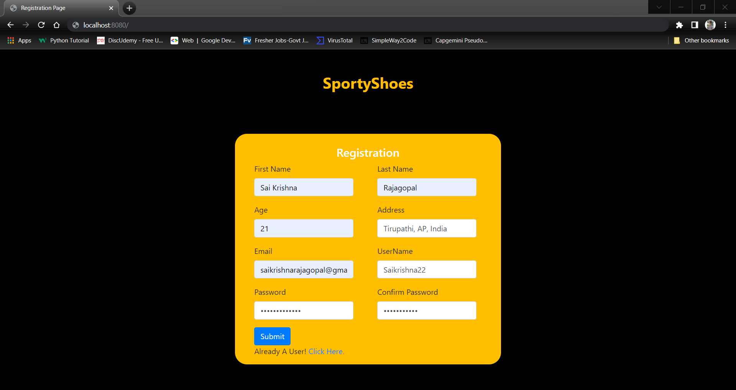

**Shopping Cart:**

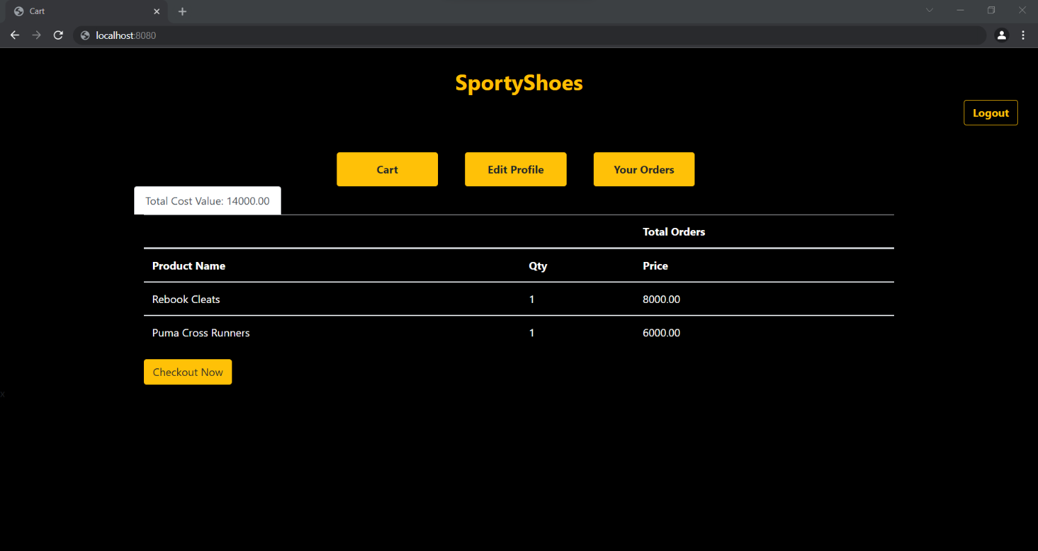

**Shopping Checkout:**

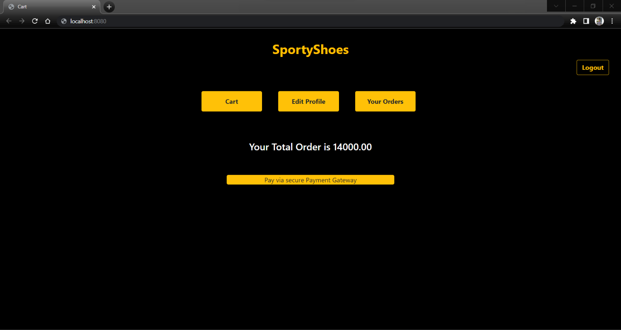

**Payment Gateway:**

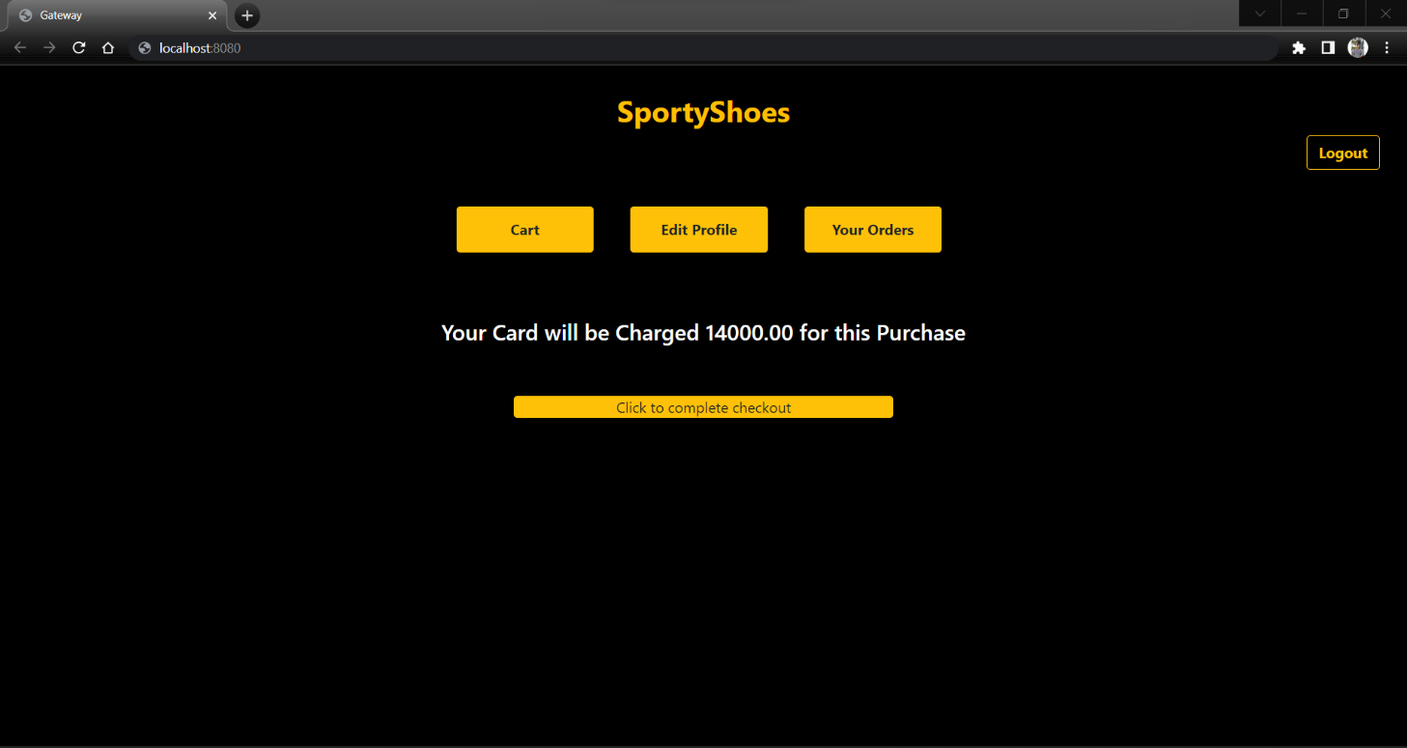

**Your Orders:**

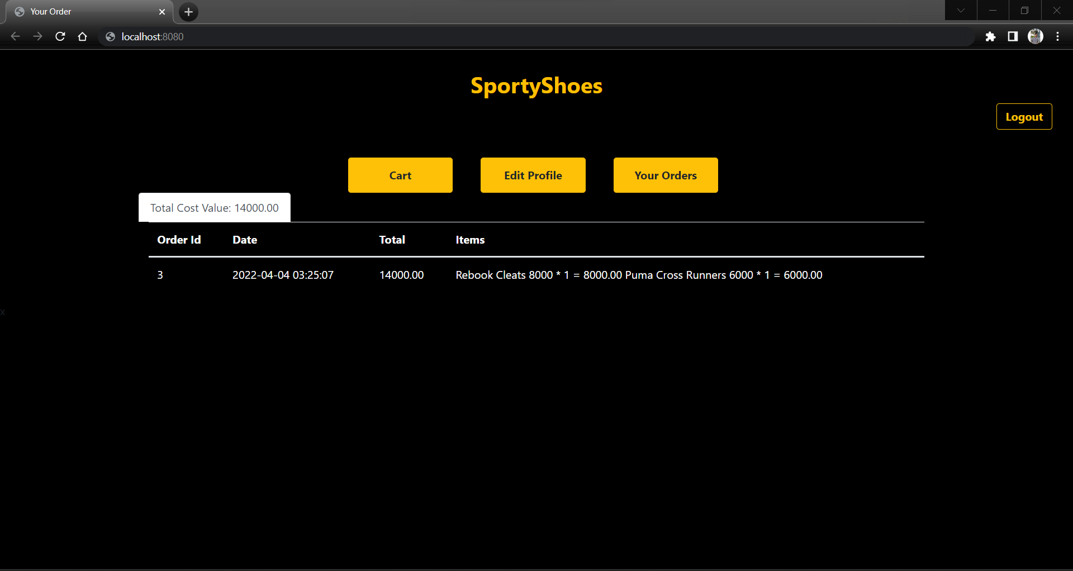

**GIT:**

